Configuration of the mezzanines PCB in the Slow Monitoring Modules

Four jumper are available on each mezzanine: J1, J2, J3 and J4, to select different path of the signals and perform different operation. For each jumper the position of pin 1 is marked with a with dot.
J1: Select the input of the antialias filter: 1-2 from the voltage input, 2-3 from the current input;
J2: Select the probe supply voltage: 1-2 None, 2-3 +5.2 V;
J3: Select the input character: 1-2 Differential, 2-3 Single Ended;
J4: Select the input type: 1-2 Voltage, 2-3 Current;

Note that it is mandatory to set J3 on 2-3 if J2 is set on 2-3. Also it is mandatory to set J4 on 2-3 if J1 is set on 2-3.
Since the jumper pattern also affects the front connector behavior, for each configuration it is important to check the pin meaning.
The following table summarize all the possible valid configuration and the input/output pin
Conf N. | Input | J1 | J2 | J3 | J4 | 1 (Left pin) | 3 (Right pin)
1 | Differential Voltage | 1-2 | 1-2 | 1-2 | 1-2 | V- input | V+ input
2 | Single Ended Voltage | 1-2 | 1-2 | 2-3 | 1-2 | GND | V input
3 | Voltage from a probe (e.g. humidity, pressure) | 1-2 | 2-3 | 2-3 | 1-2 | +5.2 output | V input
4 | Current from a probe (e.g. temperature) | 2-3 | 2-3 | 2-3 | 2-3 | +5.2 output | I input

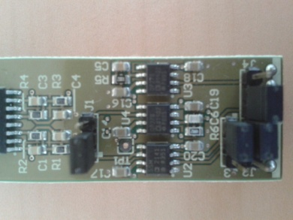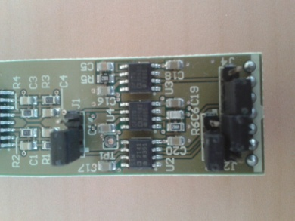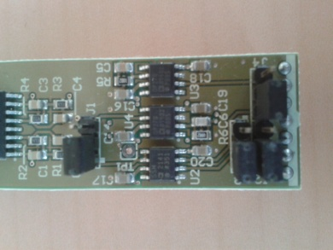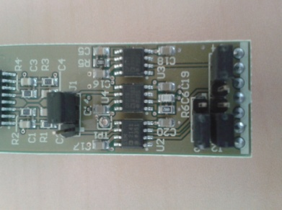
Configuration 1 Configuration 2 Configuration 3 Configuration 4

Calibration of selected probes
For AD590 temperature probes using the standard mezzanine, the temperature can be obtained by using the following formula:
T(°C)=2.004 V + 27.15
being V the output voltage of the mezzanine and the voltage acquired by the ADC.
Example temperature probe configuration:
BC_PROBE 0 NEB_W1_TE1 2.004 27.15 0.1 8 degC
Since the output voltage is in the range ±10 V the available temperature range goes from 7.11°C to 47.19°C. It is possible to change this range by changing the resistor R5 of the mezzanine, that provides for the final gain. The standard value is R5=49.9 kΩ.
For HIH-5030 humidity probes, using the standard mezzanine and assuming the standard voltage supply (5.2 V), the humidity (%RH) can be obtained by:
H(%)=30.237 V – 23.821
Example Humidity probe configuration:
BC_PROBE 14 NEB_W1_HU 30.237 -23.821 0.1 8 RH
For MPXA4115A6U pressure probe, using the standard mezzanine and assuming the standard voltage supply (5.2 V), the pressure, in kPa, can be obtained by:
P (kPa)=21.367 V + 10.556
Example Pressure probe configuration:
BC_PROBE 15 NEB_W1_PRES 213.67 105.56 0.1 8 hPa

Cabling of a”triplet”
