Indice delle lezioni
1. Sensori: Principi di funzionamento, caratteristiche comuni a tutti i sensori e trasduttori. Esempi di sensori: Velocità, Posizione, Pressione, Temperatura, Sensori di radiazione, di luce, Fotodiodi, CCD.
2. Sistemi e modelli matematici – nozioni di base sui controlli automatici
3. Condizionamento dei segnali di misura: necessità, amplificatori operazionali: varie configurazioni, Filtri.
4. Digitalizzazione delle informazioni: DAC, ADC, e loro caratteristiche principali, esempi di tecniche di conversione. Teorema del Campionamento, alias, effetto del sovracampionamento e decimazione
5. Trasmissione delle informazioni: Generalità, varie topologie, trasmissione seriale, trasmissione parallela, sincrona/asincrona. Reti e protocolli di rete TCP/UDP IP. Caratteristiche dei bus: linee dati, linee indirizzi, linee di controllo. Arbitraggio
6. (optional) Sistemi operativi e S.O. in real time. Microcontrollori vs microcomputer, linee di I/O analogiche e digitali

General characteristics of sensors
The first step for a data acquisition system is the sensor. Sensors are devices capable of transforming the physical quantity to measure into a signal that can be elaborated. A sensor is composed by an input interface, a transducer and an output interface.
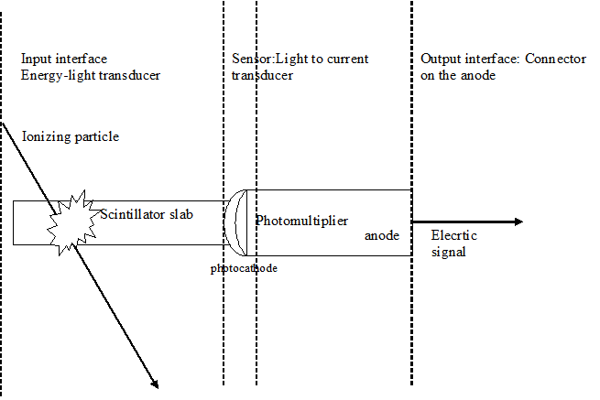
Figure 1-1: An example: a cosmic radiation sensor with scintillator and a photomultiplier
The transducer – the main component of the sensor – is a device that transforms a form of energy in an electric signal. An example is the thermoresistance; it changes its resistance as a function of the temperature, thus it is a sensor that translates a change in temperature into a change of electric resistance that can be sensed as a change of potential at its extremes when a current is supplied.
As one can imagine, often the distinction among transducer and sensor is not net, and, in the everyday practices they are mostly synonyms.

Physical quantities and signals
Physical quantities that can be sensed by a sensor can be classified in:
- Continuous quantities: can assume continuous values within a certain interval, i.e. the measurements taken in two infinitely near points can assume any of the values within the measurement interval) .
- Discrete quantities: the result of a measurement can assume only a set of discrete values, e.g. the sense of rotation can be +1 or -1, or the number of particles emitted can be only an integer.
The information linked to continuous quantities are said to be analogic signals, while those pertaining to discrete quantities are associated with logic signals – for two possible values only – or codified signals for more than two values admissible.
An analogic signal is continuous in time and can assume a continuous set of values. The acquisition system, take some time to elaborate the signal in input, so it will not be capable of following the evolution of the signal in every moment but it will sample it at different discrete time intervals. Also, the precision of the elaborators, does not permit to distinguish two infinitely near measurements, so, an approximation is needed to the nearest value allowed by the resolution of the sampler. This operation is the quantization of the sampled signal. The quantized information taken at discrete time intervals is the digital signal. The digitization and the properties of sampled signals are the object of lesson xxx
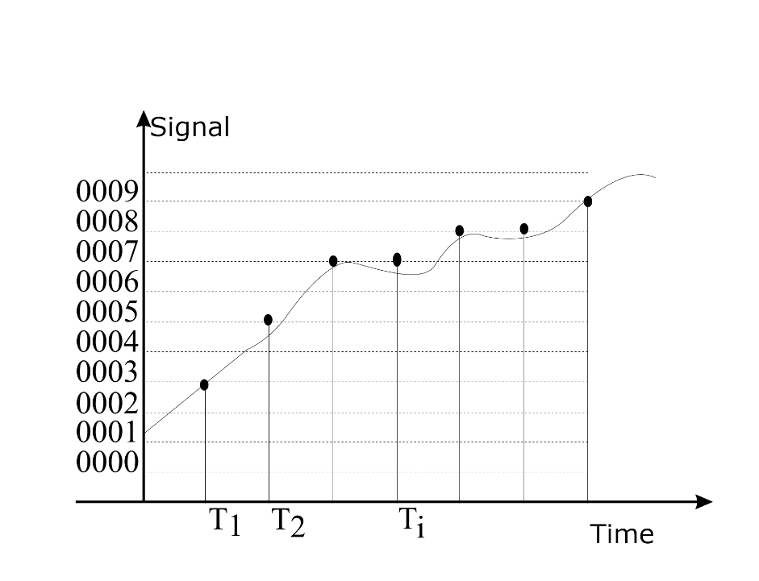
Figure 1-1-2: Sampling a continuous signal at regular intervals. The dots represent the nearest to true values permitted by the sampler resolution.

General functional characteristics of sensors

Static characteristics
If, like in systems theory, we represent a sensor as a “black box” with one or more inputs and one or more outputs, we can establish a input-output relationship that is known as the sensor’s characteristics. This quantity, when calculated for input signals that do not change in time, or change slowly enough to be considered not influent on the sensor response, is a pure algebraic relationship that is called static characteristics.
Figure 1-1-3: A sensor with N inputs and M outputs
Sensor
X₁
X₂
X_{N}
Y_{M}
Y₁
Calling the nominal inputs/outputs with the capital X and Y, and the actual values with the lowercase letters, we can write the static model of the sensor as the set of M equations: $y_{i}=f\left(x_{1}…x_{N}\right)$
Then, with respect to the Nominal values we can write: ${Δy}_{i}=y_{i}- Y_{i} =y_{i} -f\left(X_{1}…X_{N}\right),$ and, linearizing:
$$Δy_{i}=\sum_{j=1}^{N}{a_{i}^{j}}Δx_{j}; a_{i}^{j}=\frac{dy_{i}}{dx_{j}}$$
i.e. an algebraic expression. A typical example of such a linearization is the static hybrid parameters model of a transistor, as a 2x2 system.

Dynamic characteristics
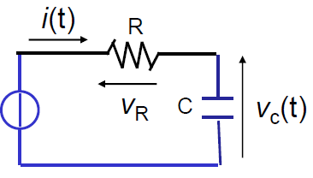
When the signal varies in time with frequencies high enough to affect the sensor’s response, it is necessary not only the equations linking input and output variables, but also the link of in/out time derivatives. This accounts for the dynamic characteristics of the sensor, that now is a set of differential equations.
Figure 1-1-4: RC Series schematics
For example, if the sensor behaves as an RC-series, we must write for the voltage $V_{o}$across the capacitor:
$$\begin{matrix}I_{in}\left(t\right)=C\frac{dV_{o}\left(t\right)}{dt} \\ V_{in}=RI_{in}+V_{o}=RC\frac{dV_{o}\left(t\right)}{dt}+V_{o}\end{matrix}$$
I.e.
$$\frac{dV_{o}\left(t\right)}{dt}=-\frac{V_{o}\left(t\right)}{RC}+\frac{V_{i}\left(t\right)}{RC}$$

$$x=V_{o};y=x;u=V_{i} \\ ⇒\left(\begin{matrix}\dot{x} \\ y\end{matrix}\right)=\left(\begin{matrix}A & B \\ C & D\end{matrix}\right)\left(\begin{matrix}x \\ u\end{matrix}\right)=\left(\begin{matrix}-1/RC & 1/RC \\ 1 & 0\end{matrix}\right)\left(\begin{matrix}x \\ u\end{matrix}\right)$$
Where we expressed the system of equations linking input, output and their derivatives in matrix form. This will be clear in the part dealing with systems theory, just note that in this representation, it is a set of linear equations not depending on the time, i.e. a Linear Time -Invariant system (LTI).

Linearity
A system is linear if its characteristics Y=f(X) satisfies the distributive property w.r.t. the sum:
$$f\left(c_{1}x_{1}+c_{2}x_{2}\right)=c_{1}f\left(x_{1}\right){+c}_{2}f\left(x_{2}\right);∀c_{1},c_{2}∈R$$
For a linear transducer, the linearity is expressed as Y=kX, where the constant k is the linear gain.
With this definition, an offset breaks the linearity, in fact: if Y=f(X)=kX+d; then f(X1+X2)=K(X1+X2)+d that is different from the sum of the two measurements Y(X1)+Y(X2)=kX1+d+kX2+d=k(X1+X2)+2d.
We can define a linearity error as the maximum deviation from the best linear fitted characteristics. In percentage, the non-linearity error:
$$ϵ_{NL\%}=100⋅\frac{ΔY}{Y_{M}-Y_{m}}$$
Where the difference at the denominator is the measurement range.
The gain error is the difference between the gain of the fitted line w.r.t. the ideal transducer linearity gain.

Resolution, precision and accuracy
Resolution is the maximum input variation that does not give rise to an output change, i.e. the minimum possible read-out value.
Precision is a measure of the repeatability of the measurement. It can be quantified as the spread of the repeated measurements around a mean value:
$$ϵ_{P}=100⋅\frac{{\left|E\right|}_{Max}}{Y_{M}-Y_{m}}$$Where ${\left|E\right|}_{Max}$ is the maximum spread (or, more often ${\left|E\right|}_{Max}=3σ$).
Accuracy is the a measure of the deviation of the sensor output from the true value of the input, i.e. the value an ideal sensor would give.
$ϵ_{A}=100⋅\frac{Δ}{Y_{ideal}}$
Figure 1-1-5: Precision and accuracy
Accurate not precise
Precise and accurate
unprecise and inaccurate
Precise not accurate
Sensitivity is the maximum sensor’s output variation to input maximum variation ratio:
$$S=\frac{Y_{M}-Y_{m}}{X_{M}-X_{m}}$$
All these quantities, can be functions of the frequency if the sensor characteristics depend on it.

Some classification of sensors
We can classify sensors in categories, following some of their main physical characteristics:
- Continuous output sensors: all the information is acquired, e.g. a photodiode
- Logic output sensors: only part of the information is acquired, e.g. a threshold detector
- Modulating sensors: need a service source of energy and the object of the measurement modulates a field, e.g. a laser speed-meter
- Self-exciting sensors: do not need a source of energy, e.g. a thermometer.

Physics of sensors
Sensors use several physics properties to accomplish their tasks. Here we try to give a short list with examples:

Resistive sensors
Here, we mostly use the relationship between the resistance R , the length L and the section S of the conductor through the resistivity:
$$R=ρ\frac{L}{S}$$
If a difference of length is sensed the resistance is changed accordingly, realizing a position or a length sensor.
If is the section to change, the variation of resistance can realize a strain-meter or a deformation meter.
The resistivity is a function of the temperature and in certain cases of the illumination. For example, if we consider the conductivity (the inverse of resistivity) as a function of the carrier densities n and p and their mobility:
$$σ=e\left(μ_{e}n+μ_{h}p\right)$$
It increases with temperature, as the density of carriers in conduction band incr witheases the Maxwell-Boltzmann distribution:
$$n=2{\left(\frac{kT}{2πℏ^{2}}\right)}^{\frac{3}{2}}{\left(m_{e}m_{h}\right)}^{\frac{3}{4}}e^{\frac{-E_{g}}{2kT}}$$
Where E_{g} is the energy gap between valence and conduction band. The resistance decreases accordingly, so it is possible to realize a thermoresistance, i.e. a temperature sensor.
With the same equations is clear that if we illuminate the semiconductor with light of frequency large enough to promote carriers in conduction band: $hν≥E_{g}$, we realize an illumination sensor.

Inductive sensors

3. Acquisition and control chain

3.1 Signal conditioning
Sensor
Signal conditioning
Signal digitize (ADC)
On-board elaboration
DAC
Control signal
analog signal
digital signal
analog signal
Signal conditioning
Actuator
analog signal
Storage/ext elab.
Transmit data
digital signal
Threshold and combining
Control signal (logic)
analog signal
Raw data

3.1.1 Necessity of conditioning
To acquire the signal from sensors, it is often necessary to amplify, filter, adapt it before passing it to the digitizer or other instrumentation - e.g. a scope. These operation are collectively called signal conditioning. To make a practical example, if the sensor exit is a continuous voltage between 0 an 10 V and the digitizer input accepts a voltage from -3V to 3V, to use the whole digitizer scale, it is necessary to adapt the sensor’s signal to the ADC input: i.e.
- Add an offset of -5V, to change the scale 0 to -5
- Reduce the [-5 , 5]V range to [-3, 3]V
Another typical case, is when the sensor’s output id very feeble, e.g. for a thermocouple. In this case, the signal must be amplified. This operation must be performed as much as possible near the signal source, so to amplify the signal without amplifying the noise picked-up during the transport from the sensor to the digitizer.

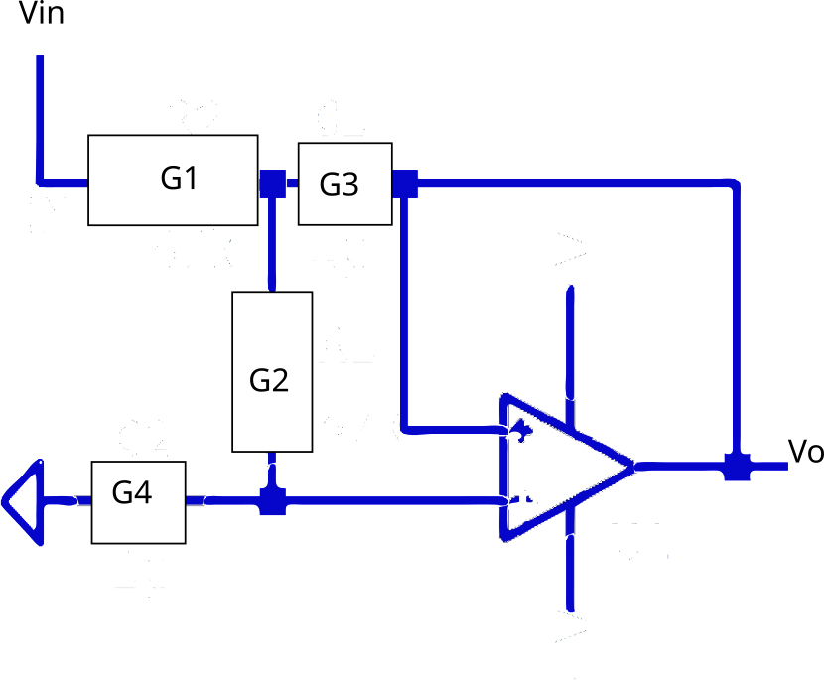
A
B
Figure 0-1: A II order filter with Op-Amp
Let’s calculate the TF of a II order filter as in figure, where the G’s are the complex conductances $G_{i}=1/Z_{i}$:
In A:
Thus:
$$G_{1}\left(V_{A}-V_{in}\right)=G_{2}\left(V_{B}-V_{A}\right)+G_{3}\left(V_{0}-V_{A}\right)$$
$$V_{A}\left(G_{1}+G_{2}+G_{3}\right)-G_{1}V_{in}=G_{2}V_{B}+G_{3}V_{0}$$

In B:
$$\left\{\begin{aligned}V_{B}=V_{0} \\ G_{4}V_{B}=G_{2}\left(V_{A}-V_{B}\right)\end{aligned}\right. \\ ⇒\left(V_{A}-V_{0}\right)=\frac{G_{4}}{G_{2}}V_{0}$$

So
$$V_{A}=\frac{\left(G_{4}+G_{2}\right)}{G_{2}}V_{0}$$
And, substituting:
$$G_{1}\left(V_{A}-V_{in}\right)=-\frac{G_{4}}{G_{2}}V_{0}\left(G_{2}+G_{3}\right) \\ V_{in}G_{1}=\left[\frac{G_{1}}{G_{2}}\left(G_{2}+G_{4}\right)+\frac{G_{4}}{G_{2}}\left(G_{2}+G_{3}\right)\right]V_{0} \\ Trf=\frac{V_{0}}{V_{in}}=\frac{G_{1}G_{2}}{G_{1}\left(G_{2}+G_{4}\right)+G_{4}\left(G_{2}+G_{3}\right)}$$
By choosing the couple of conductances it is possible to realize a low pass, high pass or a resonant filter.
Now, for a low pass filter:
$$G_{1}=1/R_{1};G_{2}=1/R_{2} \\ G_{3}=sC_{1};G_{4}=sC_{2}$$
$$Trf=\frac{1}{s^{2}\left(C_{1}C_{2}R_{1}R_{2}\right)+s{\left(R_{1}+R_{2}\right)C}_{2}+1}=\frac{1}{s^{2}+2as+\left(a^{2}+b^{2}\right)}$$

Where a and b are respectively the real and imaginary part of the poles
$p_{1,2}=a ±i b$
For a Butterworth, the poles are at $±\frac{π}{4}$in the negative real part of unit circle, i.e.: $p_{1,2}=\frac{\sqrt{2}}{2}±\frac{\sqrt{2}}{2}i$
thus:
$$\left(C_{1}C_{2}R_{1}R_{2}\right)=1 \\ {\left(R_{1}+R_{2}\right)C}_{2}=2a$$
By calling ${R_{1}C_{1}R_{2}C}_{2}={1/ω}_{c}^{2}$ and ${\left(R_{1}+R_{2}\right)C}_{2}=2ξ/ω_{c}$ with $ξ=\left(R_{1}+R_{2}\right)/R_{2}$ , then, we obtain:
$$Trf=\frac{ω_{c}^{2}}{s^{2}+2ξω_{c}s+ω_{c}^{2}}$$

The third equation comes from the choice of the cut frequency:
$${R_{1}C_{1}R_{2}C}_{2}=ω_{c}^{-2}={\left(\frac{1}{2πf_{c}}\right)}^{2}$$
By putting R1=R2=1 then, C1C2=1 i.e. C1=1/C2 and $C_{2}=a=\frac{\sqrt{2}}{2}⇒C_{1}=\sqrt{2}$
If s=i$ω$, at $ω=ω_{c}$, $Trf=ω_{c}^{2}/\left(-ω_{c}^{2}+2ξ{ ω}_{c}^{2}+ω_{c}^{2}\right)=1/2iξ$, so at the cut frequency, the output is ½ the input and the phase $ϕ=\frac{π}{2}$
To find the components, we can choose one parameter arbitrarily and find the others, e.g., if I want $f_{c}=1kHz$, if we choose $R_{1}=R_{2}=10kΩ$:
$$R_{1}R_{2}={10}^{8} \\ \left\{\begin{aligned}C_{1}C_{2}=1 \\ C_{1}C_{2}R_{1}R_{2}=\frac{1}{{\left(2πf_{c}\right)}^{2}}\end{aligned}\right. \\ C_{1}C_{2}⋅{10}^{8}=\frac{1}{{\left(2πf_{c}\right)}^{2}}⇒\frac{1}{{\left(2π\right)}^{2}}=C_{1}C_{2}⋅{10}^{14} \\ C_{1}^{'}=\frac{C_{1}⋅{10}^{-7}}{2π}=1.414/2π⋅{10}^{-7}=22.5nF$$

$$C_{2}=1/C_{1}⋅{10}^{-7}/2π=11.3nF$$ 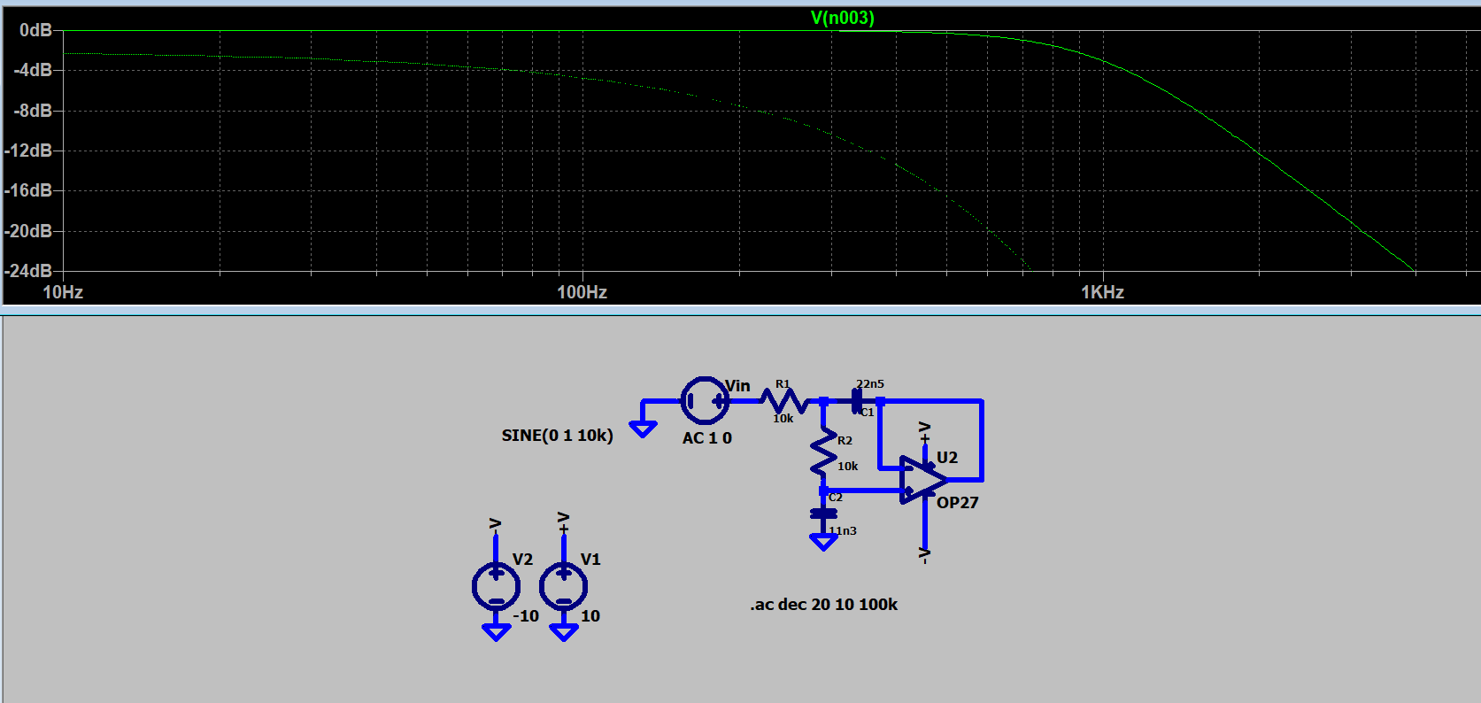
Figure 0-2: pspice simulation of the 2nd order Butterworth filter and its transfer function vs frequency

To build a 4th order filter, one can cascade two 2nd orders as in figure below .
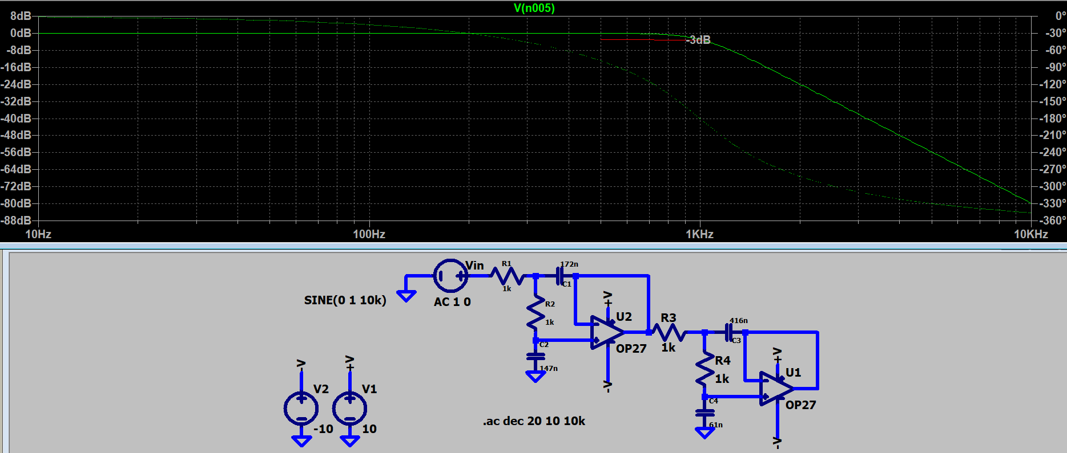
Figure 0-3: Top transfer function vs frequency, bottom schematics of the 4th order Butterworth filter

The transfer function is the product of the two. To be a Butterwoth, all poles must be equispaced on the unit circle and with real part negative, so the angles are $\frac{π}{8}$ apart. We obtain:
Poles (a ± ib) Quadratic Expression
-0.9239 ± i0.3827 s² + 1.8478s + 1
-0.3827 ± i0.9239 s² + 0.7654s + 1
If we fix the resistors to be 1, we remain with the conditions:
$$\left(C_{1}C_{2}\right)=1=ω_{c}^{-2} \\ {2C}_{2}=2a$$
So $C_{2}=0.9239$ and $C_{1}=1.082$, $C_{4}=0.3827$, $C_{3}=2.6113$; this sets the capacitors-to-resistors rate.
So, ideally, if we set the resistors to $R=1kΩ$ we get $C= 1mF$, but the cut frequency remains 1Hz. If we want it to be 1 kHz, we still must reduce the capacitor by a factor $2π⋅1000$, we obtain
C2=147nF
C1=172nF
C4=61nF
C3=416nF

Spectral behaviour of sampled signals
Let’s denote the continuous signals as functions, f(t), of the continuous time while the sampled signal is a function F(n) of the discrete time represented by the sample number n. Let us begin to examine the differences between the continuous and the discrete version of the complex exponential function. For the continuous $f\left(t\right)=e^{iωt}$; the larger is ω the larger is the rate of oscillations and is periodic for any value of ω. The discrete counterpart has a different behaviour, in fact, considering the complex exponential with frequency $\left(Ω_{0}+2π\right)$ :
$$F\left(n\right)=e^{i\left(Ω_{0}+2π\right)n}=e^{iΩ_{0}n}e^{2iπn}=e^{iΩ_{0}n}.$$
As we see it has the same frequency as the function with frequency $Ω_{0}$, the same being for signals with frequency $\left(Ω±2π\right)$, $\left(Ω±4π\right)$. Therefore, in considering discrete time complex exponentials we need to consider only an interval of length $2π$.
As far as the periodicity is concerned, in order for the signal to be periodic of period N, it must satisfy the relation:
$$F\left(n\right)=F\left(n+N\right)⇒e^{iΩn}=e^{iΩ\left(n+N\right)}$$
or equivalently: $e^{iΩN}=1$, that is $ΩN = 2kπ$, i.e. $e^{iΩN}$is not periodic for any $Ω$, but only for $Ω=2πk/N$
The discrete-time sequence obtained by sampling a continuous complex exponential signal at equally spaced points in time is:
$X\left[n\right]=e^{iωnT}$
that is a discrete time exponential of period $ωT$, being T the interval between the samples, i.e. the reciprocal of the sampling pulsation: thus, if $ω_{s}=2π/T$ is the sampling frequency, the function will be periodical only if $ω/ω_{s}$ is a rational number.

3.2.1 The sampling Theorem
Any continuous signal x(t), sampled with a period T can be represented in terms of a sum:
$$x_{p}\left(t\right)=\sum_{n=-∞}^{∞}{x\left(nT\right)δ\left(t-nT\right)}$$
By Fourier transforming this expression, we see that it is the convolution:
$$X_{p}\left(ω\right)=\frac{1}{2π}\left[X\left(ω\right)*P\left(ω\right)\right]$$
where
$$P\left(ω\right)=\frac{2π}{T}\sum_{k=-∞}^{∞}{δ\left(ω-kω_{s}\right)}$$
so
$$X_{p}\left(ω\right)=\frac{1}{T}\sum_{k=-∞}^{∞}{X\left(ω-kω_{s}\right)}$$

That is $X_{p}\left(ω\right)$ is a sum of replicas of $X\left(ω\right)$ scaled of 1/T
If the spectrum of the original signal has a maximum frequency $ω_{M}$, then if $ω_{M}<\left(ω_{s}-ω_{M}\right)$ i.e. $$ω_{s}>2ω_{M}$ there is no overlap of the replicas and the signal can be recovered exactly from the sampled signal by applying a low-pass filter with cut frequency $ω_{M}<ω_{c}<\left(ω_{s} -ω_{M}\right)$. This is what is called the sampling theorem, the frequency $ω_{s}=2ω_{M}$ is called the Nyquist frequency.
The sampling theorem can be enunciated as follows:
Given a band-limited signal x(t) with$X\left(ω\right)=0$ for each $\left|ω\right|>ω_{M}$, then x(t) is uniquely determined by its samples $x_{p}\left(nT\right)$ if
$$ω_{s}>2ω_{M}$$
where $ω_{s}=2π/T$ is the sampling frequency.

3.2.2 Numerical filters
If the representation of our signal is a series of samples x(n) sampled at intervals of T, its derivative, at first order is given by:
$$\frac{dx\left(t\right)}{dt}=\frac{x\left(nT\right)-x\left([n-1]T\right)}{T}$$
We could improve the precision, by using also the forward derivative
$$\frac{dx\left(t\right)}{dt}=\frac{x\left([n+1]T\right)-x\left(T\right)}{T}$$
And using Taylor series for both :
$$x\left(n+h\right)=x\left(n\right)+h\frac{dx}{dt}+h^{2}\frac{1}{2}\frac{d^{2}x}{dt^{2}}+… \\ x\left(n-h\right)=x\left(n\right)-h\frac{dx}{dt}+h^{2}\frac{1}{2}\frac{d^{2}x}{dt^{2}}+…$$so the difference, gives
$$\frac{x\left(n+h\right)-x\left(n-h\right)}{2h}=\frac{dx}{dt}+\frac{1}{6}O\left(h^{2}\right)$$Now, restricting to the normal incremental ratio, the second derivative is
$$\frac{d^{2}x\left(t\right)}{dt^{2}}=\frac{1}{T}\left(\frac{x\left(\left[n+1\right]T\right)-x\left(nT\right)}{T}-\frac{x\left(nT\right)-x\left(\left[n-1\right]T\right)}{T}\right)= \\ =\frac{1}{T^{2}}\left(x\left(\left[n+1\right]T\right)-2x\left(nT\right)+x\left(\left[n-1\right]T\right)\right)$$
In general the k-th derivative is:
$\frac{d^{k}x\left(t\right)}{dt^{k}}=\sum_{m=0}^{M}{b_{m}}x[k-m]$
Thus, applying the z transform: $Z\left(\frac{d^{k}x\left(t\right)}{dt^{k}}\right)=\sum_{m=0}^{M}{b_{m}}z^{m-k}=\sum_{m=0}^{M}{b_{m}}X\left(z\right)z^{-k}$
This allow us to write differential equations for discrete systems as difference equations. It means, that if the equation for a filter is:
$$\sum_{k=0}^{N}{b_{k}}\frac{d^{k}y(t)}{dt^{k}}=\sum_{m=0}^{M}{a_{m}}\frac{d^{m}x(t)}{dt^{m}}$$
We can write, for a discrete filter:
$$\sum_{k=0}^{N}{a_{k}}y\left[n-k\right]=\sum_{m=0}^{M}{b_{m}}x\left[n-m\right]⇒y\left[n\right]=\frac{1}{b_{0}}\left(\sum_{m=0}^{M}{a_{m}}x\left[n-m\right]-\sum_{k=1}^{N}{b_{k}}y\left[n-k\right]\right)$$

That is a recursive equation, since we must know all the n-N values of the exit to get the present value.
If N=0, the difference equation is non recursive and its response to a step is finite, defining the so called Finite Impulse Response (FIR) filter, the other case being infinite response (IIR).
In the most general case of the IIR, by applying the z transform:
$$Y\left(z\right)=\sum_{l=0}^{L}{a_{l}z^{-l}X\left(z\right)+\sum_{m=1}^{M}{b_{m}z^{-m}Y\left(z\right)}} ⇒ \\ \sum_{m=0}^{M}{b_{m}z^{-m}Y\left(z\right)}=\sum_{l=0}^{L}{a_{l}z^{-l}X\left(z\right)}$$
So that we can write the transfer function:
$$Y(z)=H(z)X(z)⇒H(z)=\frac{Y(z)}{X(z)}=\frac{\sum_{m=0}^{M}{b_{m}z^{-m}}}{\sum_{n=0}^{N}{a_{n}z^{-n}}}$$
A difference between the continuous and discrete time transfer function, is that in the latter, also a delay has a rational TRF; in fact, if y[k]= x[k-h], then $Y\left(z\right)=z^{-h}X\left(z\right)$ so that H(z)= $z^{-h}$.
As for the continuous case the poles of H must have real part negative for the response to be finite.
A typical example is the moving average filter (is a low pass filter). Its time definition is that the n^th exit is the average over the k preceding inputs:
$$y\left(n\right)=\frac{1}{K+1}\sum_{m=0}^{K}{x\left(n-m\right)}$$
$$Y\left(z\right)=\frac{X\left(z\right)}{K+1}\sum_{m=0}^{K}{z^{-m}} =\frac{X\left(z\right)}{K+1}\frac{1-{\left(z^{-1}\right)}^{K}}{1-\left(z^{-1}\right)}⇒ \\ H\left(z\right)=\frac{1}{K+1}\frac{z^{K+1}-1}{z-1}z^{-K}$$
This transfer function has K poles in the origin, and K zeros equispaced on the unit circle, representing the blocked frequencies. If one takes $z=e^{iω}$:
$$\frac{1}{N+1}\frac{z^{N+1}-1}{\left(z-1\right)}=\frac{1}{N+1}\frac{e^{iω\left(N+1\right)}-1}{\left(e^{iω}-1\right)}=\frac{1}{N+1}\frac{e^{\frac{iω\left(N+1\right)}{2}}-e^{-\frac{iω\left(N+1\right)}{2}}}{\left(e^{\frac{iω}{2}}-e^{-\frac{iω}{2}}\right)}e^{\frac{iωN}{2}}≈\frac{\sin{\frac{N+1}{2}}ω}{\left(N+1\right)\sin{\frac{ω}{2}}}$$
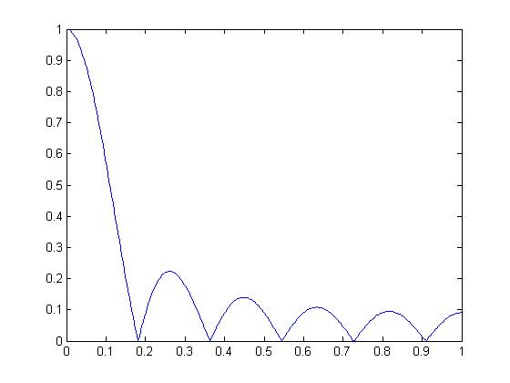
Figure 0-4: the transfer function of the MA filter is a sync.
Now let’s find the digital equivalent of a RC filter.
Figure 0-5:RC circuit
The differential equation is:
$$V=RC\frac{dV_{c}}{dt}+V_{c}$$
or, taking the complex impedances: $V_{c}=\frac{V/sC}{\left(R+1/sC\right)}=V\frac{1}{RCs+1}$ . By calling $RC=τ=1/ω_{C}$, $Y=X\frac{1}{τs+1}$, i.e.
$$H\left(s\right)=\frac{1}{τs+1}$$
Transforming the differential equation in a difference equation: x[n]=RC/T(y[n]-y[n-1])+y[n], i.e., $y\left[n\right]\left(1+τ/T\right)-y\left[n-1\right]τ/T=x\left[n\right]$. By z-transforming, one obtains: $\left[\left(1+τ/T\right)-z^{-1}τ/T\right]Y\left(z\right)=X\left(z\right)$, so:
$$H\left(z\right)=\frac{1}{\left(1+\frac{τ}{T}\right)-\frac{τ}{T}z^{-1}}=\frac{ω_{s}/ω_{c}}{\left(ω_{s}/ω_{c}+1\right)-z^{-1}}=\frac{β}{\left(β+1\right)-z^{-1}}=\frac{b}{1-az^{-1}}$$
Where $b=\frac{1}{\left(ω_{s}/ω_{c}+1\right)}$ and $a=\frac{ω_{s}/ω_{c}}{\left(ω_{s}/ω_{c}+1\right)}$.
So, given the values in figure: R=1k; C=1nF, $ω_{c}=1MHz$, if $ω_{s}=10MHz$, b=1/11; a=10/11, so the difference equation is: y[n]=0.09x[n]+0.9y[n-1]
