A measurement of the ATLAS di-muon trigger efficiency in proton-proton collisions at $\sqrt{s}$= 7 TeV.
On behalf of the ATLAS Collaboration
Corresponding author: Francesco.Conventi@cern.ch on behalf of the ATLAS TDAQ speakers committee (the actual speaker will be selected in due time)

Abstract:
The B physics programme of the ATLAS experiment includes the study of the production cross sections, the searches for rare b decay signatures which are sensitive to new physics at the TeV energy scale and the measurements of CP violation effects in B-events, such as $B_{s}^{0}$→J /ψ φ and $B_{d}^{0}$→J /ψ$K_{s}^{0}$ .
The key to the detection of these B signals in ATLAS is to achieve a high trigger efﬁciency for low-p_{T} di-muon events, keeping an acceptable trigger rate.
ATLAS developed two separates approaches for triggering on di-muon events from a resonance such as J/ψ and ϒ. The ﬁrst approach is to start from a di-muon trigger selected by the Level-1 trigger while the second is based on dedicated Level-2 algorithm.
The performance of di-muon trigger has been studied using collision data at $\sqrt{s}$= 7 TeV. Results are shown and compared to MonteCarlo predictions.

1. ATLAS Di-muon Trigger for B-physics

The ATLAS detector has a three-level trigger system: level 1 (L1), level 2 (L2) and the event
ﬁlter (EF). The output rate of the ﬁrst level trigger at a luminosity of 10 cm⁻² s⁻¹ is expected to contain about 20 kHz of events where one muon passed the transverse momentum (pT) threshold of 6 GeV.
In 2010 data taking has been possible to include even lower pT thresholds, down to the lowest threshold achievable in the level-1 hardware.
At the second level trigger this rate of events must be reduced to 1-2 kHz, of which 5-10% are available for channels of interest only to B-physics. Currently this goal is achieved for level-1 muon triggers by ﬁrst conﬁrming that a muon over the nominal threshold is reconstructed in the muon spectrometer (MS), and then conﬁrming that there is a matching track in the inner detector (ID).
This selection criterion removes many muons from K and π decays, but does not by itself produce the required rate reduction. To achieve the required rate pT thresholds need to be raised and many interesting b events are likely to be ﬁltered out.
Therefore to keep high the efficiency for B signals the Atlas collaboration has developed specific di-muon trigger algorithms which achieves high efﬁciency at level-2 for the golden channels using the identiﬁcation of relatively low-pT muons coming from J /ψ decay or other resonant sources like ϒ.
There are two possible approaches at level-2 for selecting di-muon events from a resonance such as J /ψ and ϒ. The ﬁrst approach is to start from a selected di-muon trigger already at level-1. In this approach each muon is conﬁrmed separately and the two muons are subsequently combined to form a resonance and to apply a mass cut. We will refer to this trigger as the “topological di-muon trigger”.
An alternative approach is to start with a level-1 single muon trigger and search for the second muon track inside a wide η-φ region of the inner detector and then extrapolating the track to the muon spectrometer to tag muon tracks. Since this method does not explicitly require the second muon at level-1, it has an advantage for reconstructing J /ψ even at pT lower than the lowest level-1 threshold. We will refer to this trigger as the “TrigDimuon trigger”. The basic idea if this two approaches (topological and TrigDi-muon) are illustrated in Figure 1.

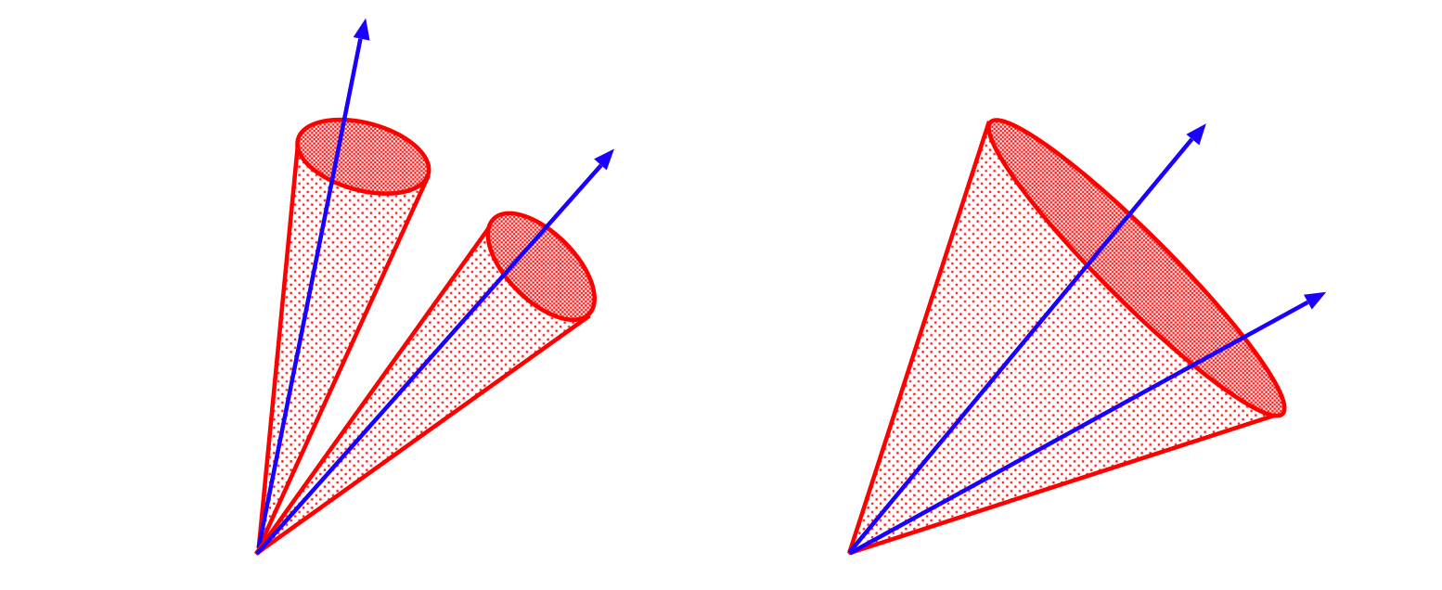
Figure 1: A schematic picture di-muon trigger, topological trigger (left) and seeded by a single level-1 muon (right).

The performance of both approaches for the di-muon trigger has been studied using 2010 collision data at $\sqrt{s}$= 7 TeV.

2. Measuring trigger efﬁciency for di-muon trigger from ATLAS data
Cross section measurements require a good understanding of the efﬁciency of the event selections. A precise understanding of the trigger efﬁciency is crucial and we must have a strategy for measuring it from data with high precision. Standard approach to di-muon trigger efficiency calculation has been proposed in recent works [1] and rely on the single muon trigger efﬁciencies, taking into account the dependence on kinematic variables of the muons.
We develope an alternative method based on Bayes theorem which not require the knowledge of the angular distribution of the decay muons from the J /ψ or ϒ and can be applied on any data stream without any bias on the efficiency measurement even if the data stream has been selected by a muon trigger item.
In this approach the efficiency for a di-muon trigger item can be written as:

$e(T_{2m})=\frac{e(T_{1m})e(T_{2m}|T_{1m})}{e(T_{1m}|T_{2m})}$

where T_{2μ} is the di-muon trigger item, $e(T_{1m})$ is the efficiency for a single muon trigger item (for example the EventFilter decision with a pT threshold of 4 GeV/c) and $e(T_{2m}|T_{1m})$ or $e(T_{1m}|T_{2m})$ are the conditional probability.
The $e(T_{1m})$ terms have been obtained with the Tag&Probe method with an uncertainty of O(1%) using 2010 data as described in [2] . The conditional probabilities could be measured directly from data without any bias. This new approach has been tested on a large MC sample first showing very encouraging results and then applied on 2010 collision data. Results for different di-muon trigger item have been obtained and compared to MonteCarlo predictions with very good agreement. Moreover the impact on the di-muon trigger efficiency measurement coming from the uncertainty on the single muon trigger efficiency has been evaluated.

REFERENCES:
1. The Atlas Collaboration, Expected Performance of the ATLAS Experiment, arXiv:0901.0512 CERN-OPEN-2008-020
2. The Atlas Collaboration, A measurement of the ATLAS muon reconstruction and trigger efficiency using J/psi decays, ATLAS-CONF-2011-021

