Dear All,
After internal Nemo collaboration discussion we send a comment to your proposal.

1) Sea Earth:
The proposed solution, (Alternative solution) (figure 2b) is accepted.

2) Connection of BUs to CTAs:
The Contractors Preferred Solution is accepted, but it’s not clear if armadillos on BU remain or not as on summary of key proposed changes it’s declared “Removal of at least one set of armadillos”.

3) Installation Methodology:

The ELETTRA proposed installation methodology is accepted.

In any case we consider that this project review have an economical impact in the contract configuration.
Unfortunately due to a very recent economical restriction of our institution it’s not possible to modify at the moment the fixed total budget. So we have received a stop to a possible variation of this contract. This situation bring us to consider the better solution maintaining the same costs.
At the moment a possible solution is shown in the attached fig. 1.

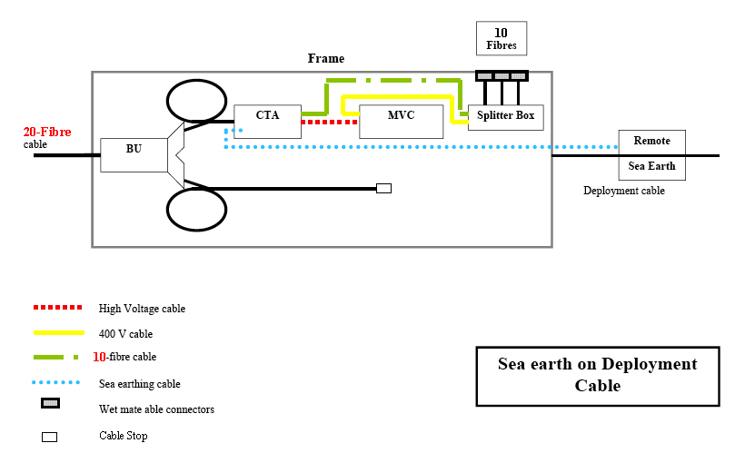

Fig. 1. Solution 1

The BU, in the solution 1, could not be necessary till the connection of a second CTA and a second MVC will be carried out. So in this case we prefer do not connect now the BU, and instead of it, connect the backbone cable directly to the CTA as shown in the fig. 2.
The solution 2 allow:

1) Due to the continuous developing of the Nemo project, more time to think to the final configuration of the power distribution system for the telescope

2) Test the BU in our laboratory with eventual implementation of the electronic controls and deployment of it, previous recovery of the Frame, later with a second CTA and further MVC.

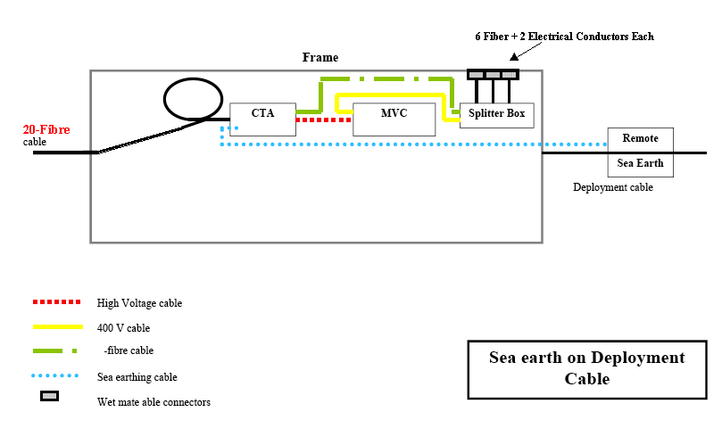
Fig. 2. Solution 2

Please let me to know your opinion about this.

